Product Name: Metal Access Panel
Product Code: BYMAPPW

General Schematic

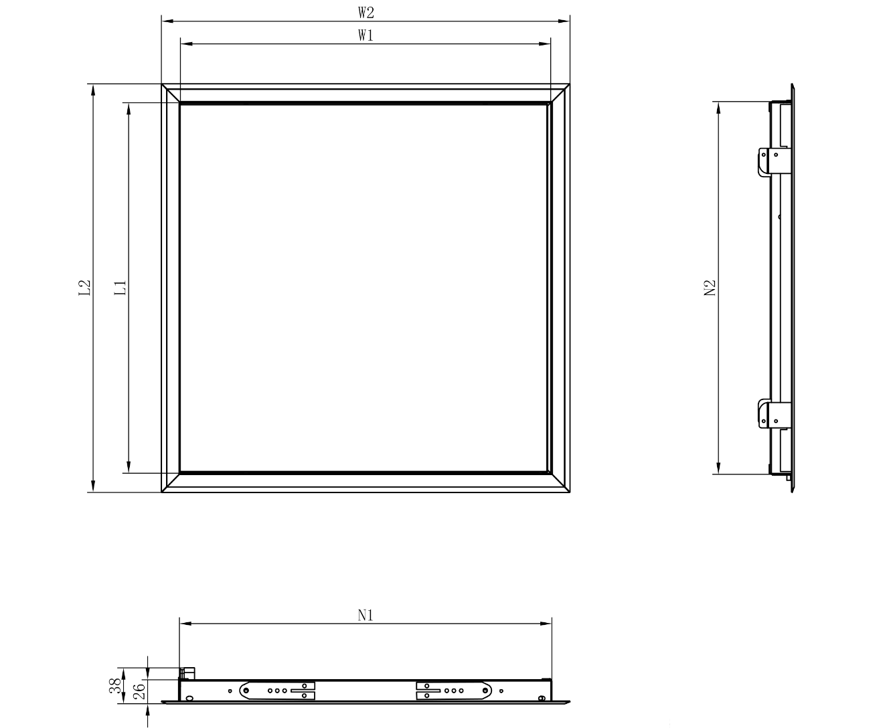

Definitions
Neck size: Nominally cited in listing title. Size of the opening that would be cut into the wall/ceiling to install the access panel. Depicted via N1, N2 in schematic
Opening size: Size of opening available for access once panel is installed. Depicted via W1, L1
Overall size: Total size of access panel as visible once installed. Depicted via W2, L2

Size chart

Product number | Nominal size  (in). | Nominal size  (mm) | Neck size  N1XN2  (mm) | Opening size  W1XL1  (mm) | Overall size  W2XL2  (mm)
BYMAPPW-0606 | 6X6 | 150X150 | 147X147 | 145X145 | 185x185
BYMAPPW-0808 | 8X8 | 200X200 | 197X197 | 195X195 | 235x235
BYMAPPW-1212 | 12X12 | 300X300 | 297X297 | 295X295 | 335x335
BYMAPPW-1216 | 12X16 | 300X400 | 297X397 | 295X395 | 336x436
BYMAPPW-1220 | 12X20 | 300X500 | 297X497 | 295X495 | 336X536
BYMAPPW-1616 | 16X16 | 400X400 | 397X397 | 395X395 | 435x435
BYMAPPW-1620 | 16X20 | 400X500 | 397X497 | 395X495 | 436x536
BYMAPPW-1624 | 16X24 | 400X600 | 397X597 | 395X595 | 436X636
BYMAPPW-1818 | 18X18 | 450X450 | 447X447 | 445X445 | 485X485
BYMAPPW-2020 | 20X20 | 500X500 | 497X497 | 495X495 | 536x536
BYMAPPW-2024 | 20X24 | 500X600 | 497X597 | 495X595 | 536X636
BYMAPPW-2424 | 24X24 | 600X600 | 597X597 | 595X595 | 636X636

Other specifications:
- 1mm galvanized steel frame and lid
- Flange frame
  - Sizes up to 18”x18” with one piece punched frame
  - 20”x20” and larger with welded frame
- White powder coating finish
- High durability and corrosion protection
- Steel bar hinge door removable
- Swing tabs for installation of fixing screws
- Two push locks. Push on centre-right of door to open / close
- Packaging: Each piece put into poly bag with shrink wrap, wrapped with foam around edges, then put into carton
- Made in China

